**15IT304J WEB PROGRAMMING**

**ASSIGNMENT**

**Topic: Web Hosting**

**Done By**

RA1611009010**191**

Vivek Mudaliar

Venue: 202/402

Faculty: **Dr.P.Supraja**

**Steps for Web Hosting:**

**Step1:** Find the free Web hosting Service and Signup your details

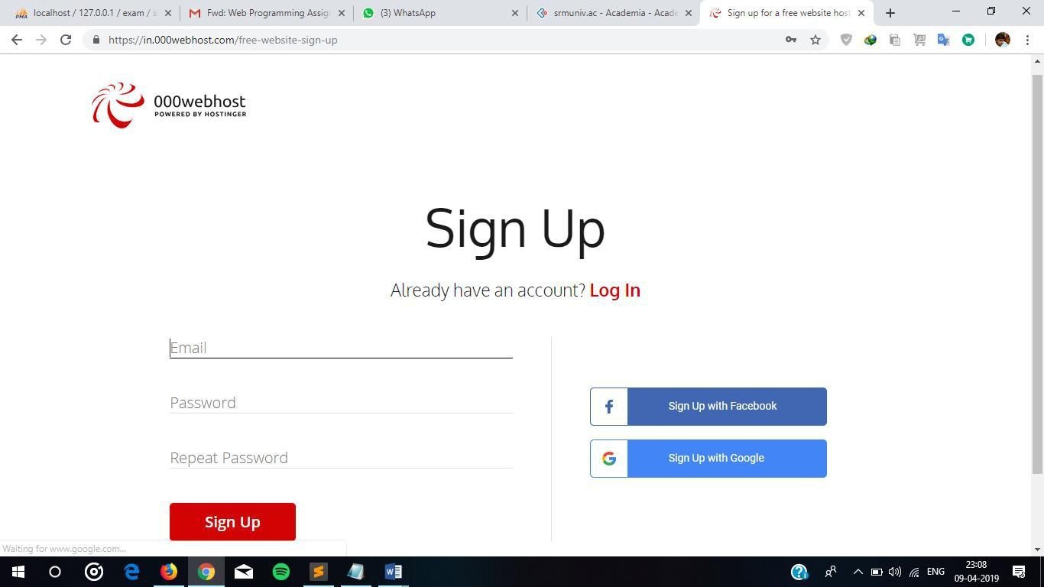

**Step2:** After the Successful Login, go to my Admin tab and create a new website by clickingon the plus icon. and enter the website name and password to create the site domain.

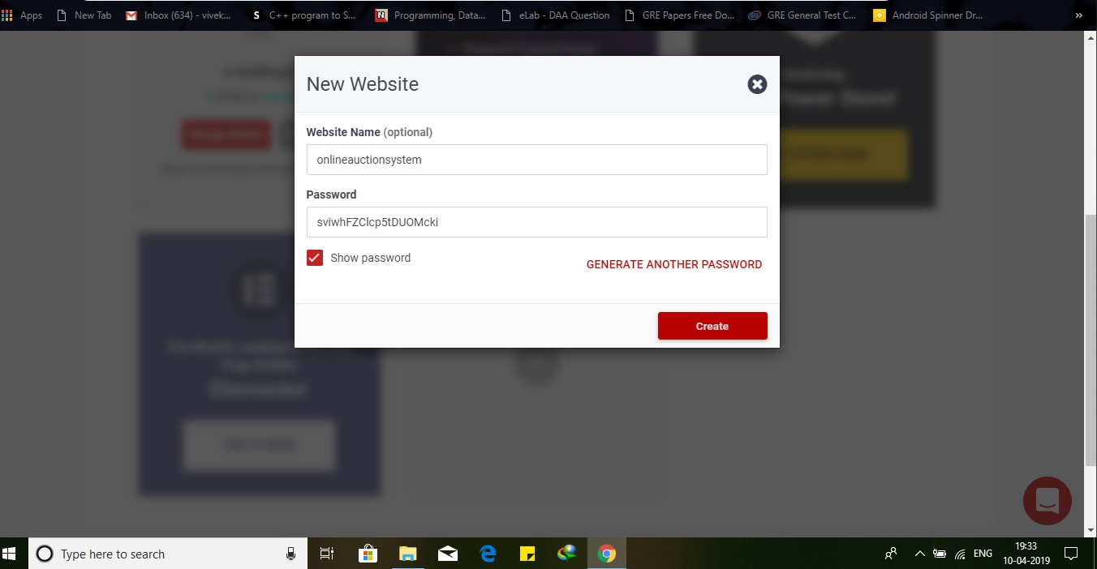

**Step3**: Give the proper unique website name otherwise it throws error and give the strongpassword and push the submit button and you will be redirected to the successful page i.e successful creation of your domain for free.

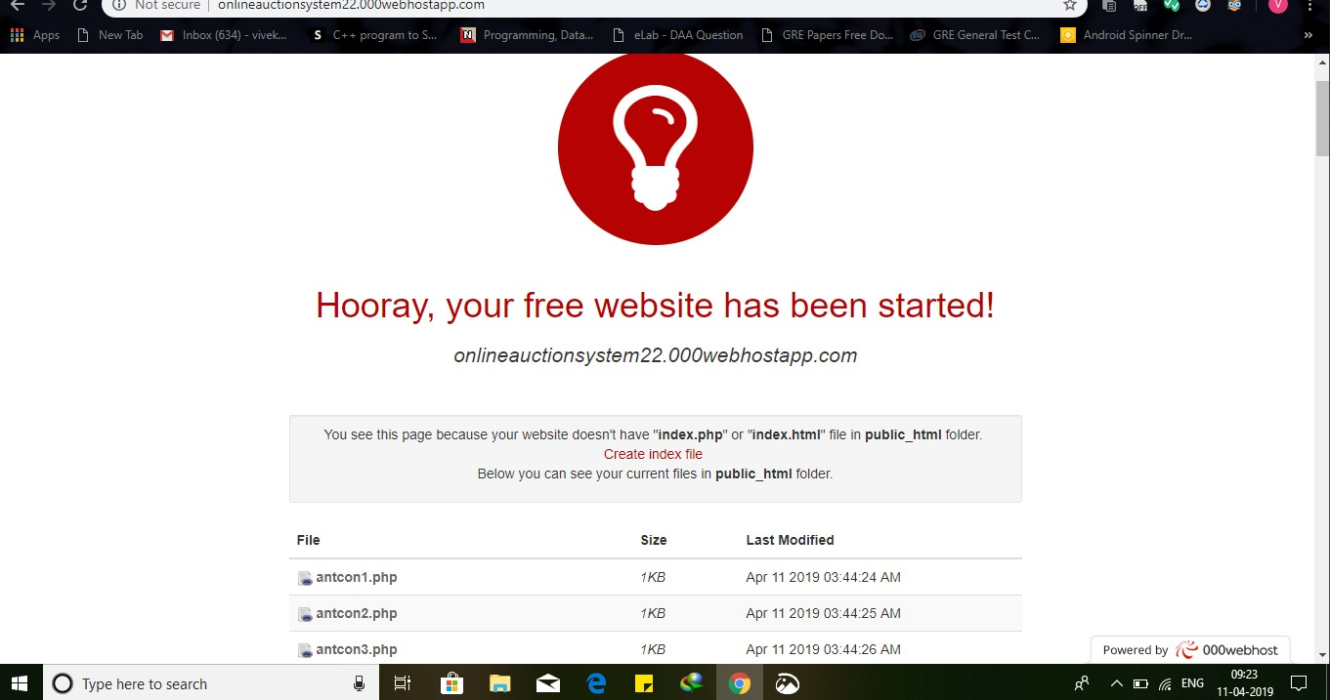

**Step4**: In the home page you will be having different type of controls over your website andthe initial step is to Build a website.

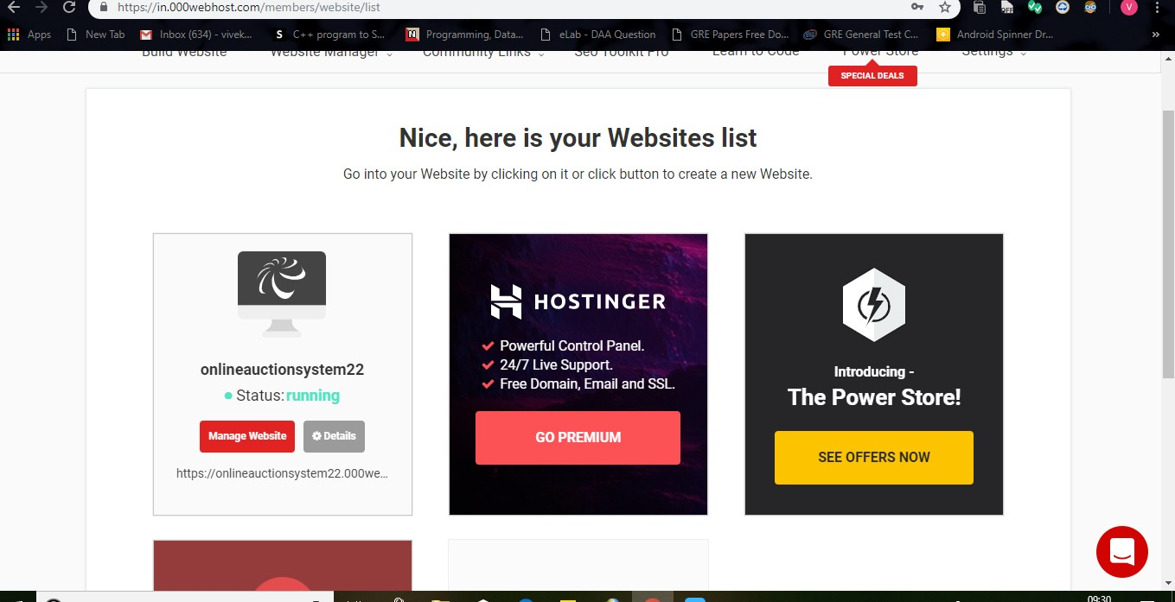

Step5: Choose the File Manger in the Drop down of web site manager and select File manager and you will Redirected to upload files page.

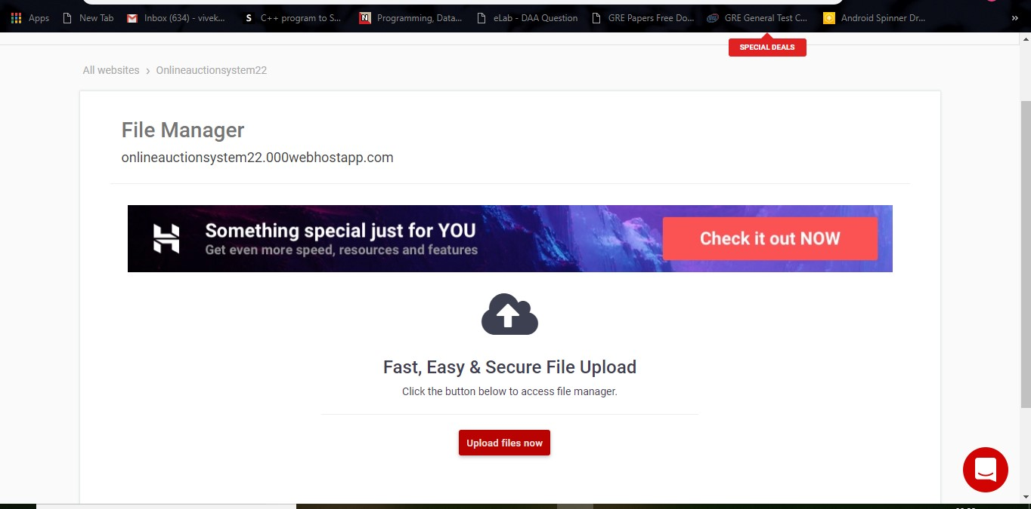

**Step5:** After the successful upload of files rename the landing page.php to index page.php.

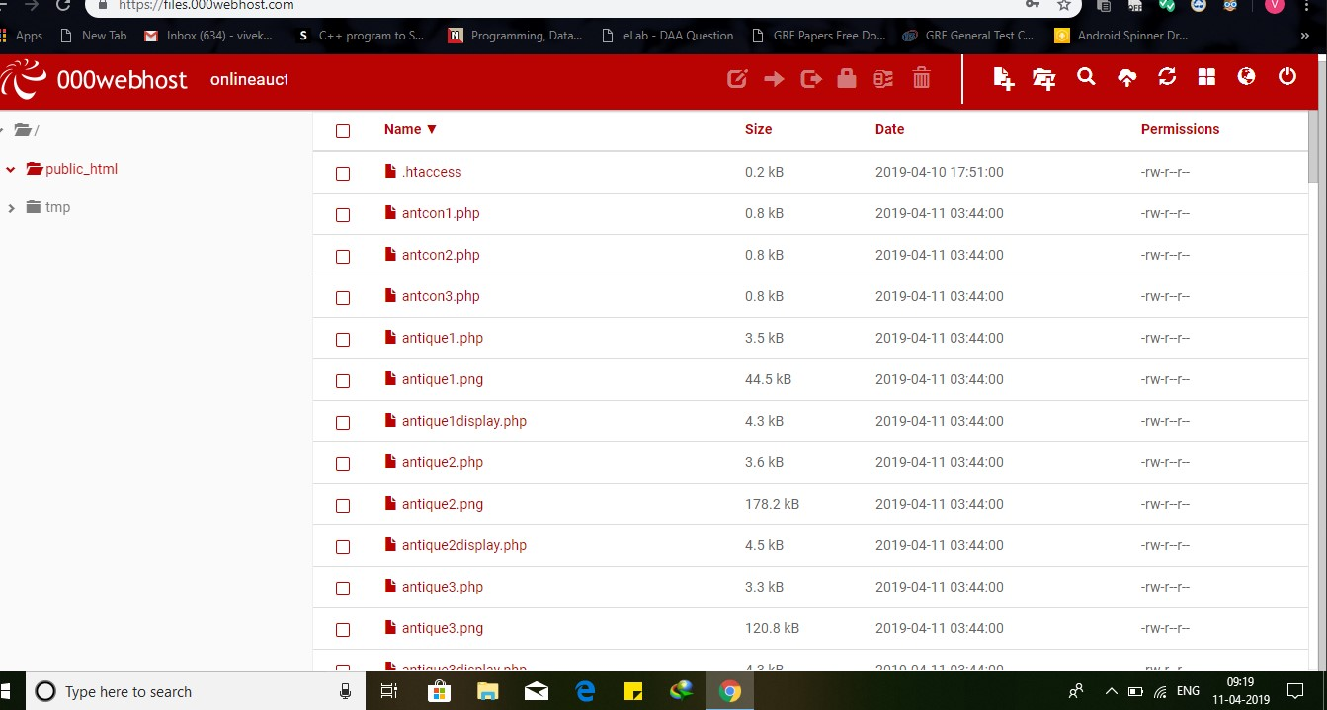

**Step6:** Now the main part comes here i.e we should create the database for our website.

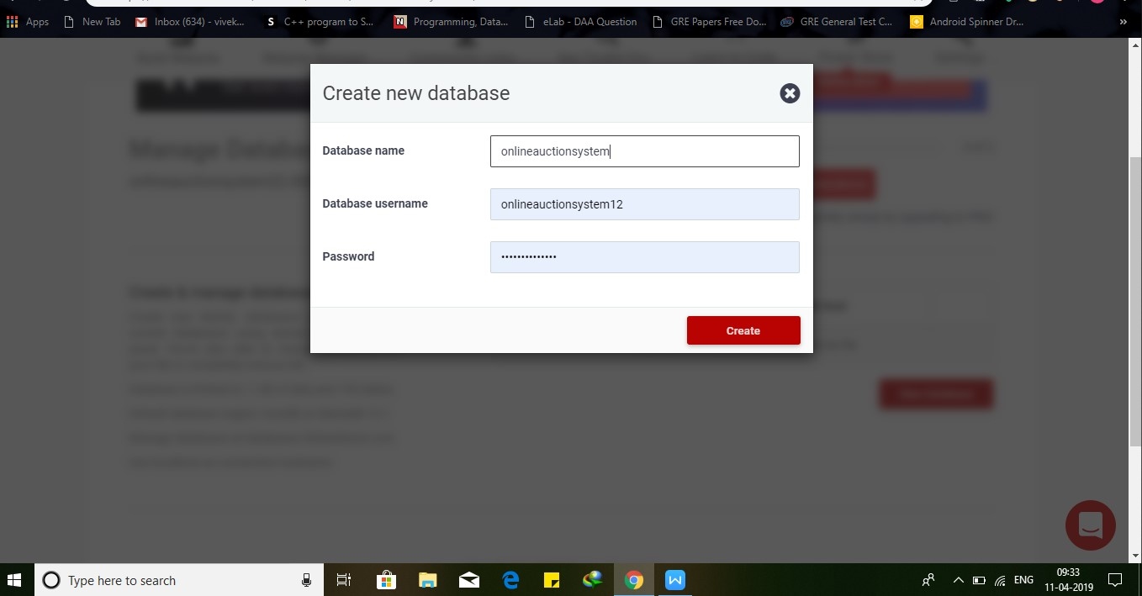

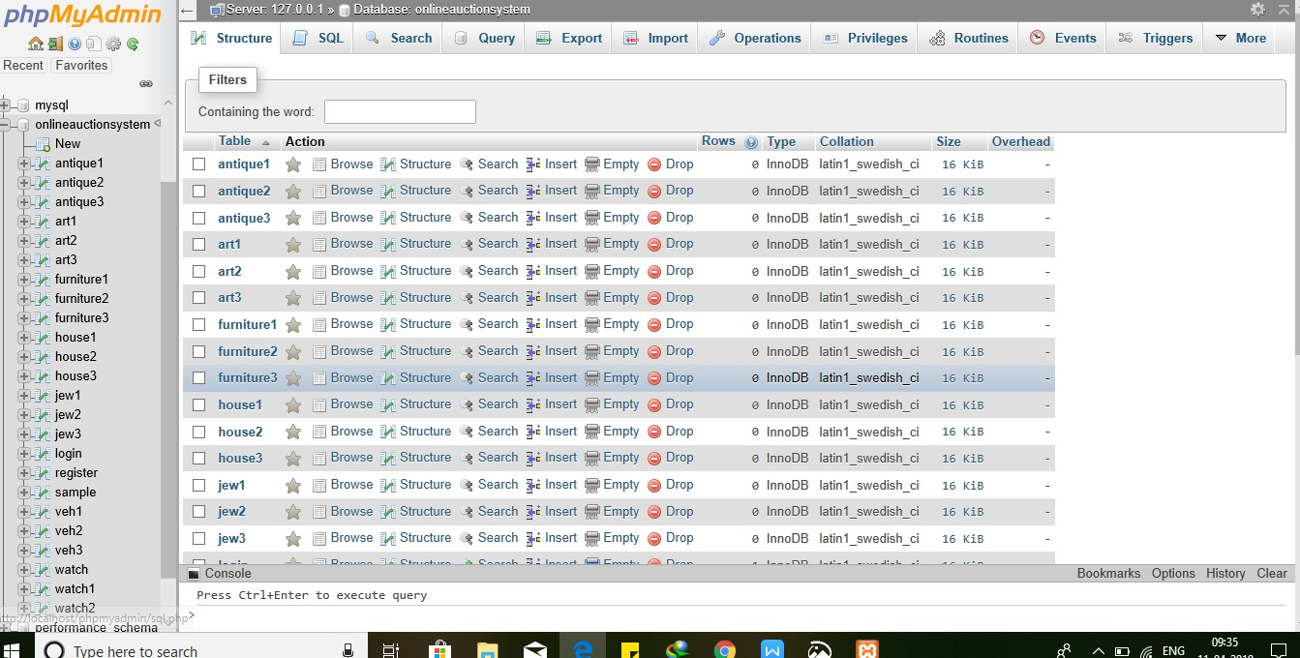

The phpmydmin database file can be imported from your localfiles.

**Step7:** After the successful creation of your database now you’re ready to open your ownwebsite globally.



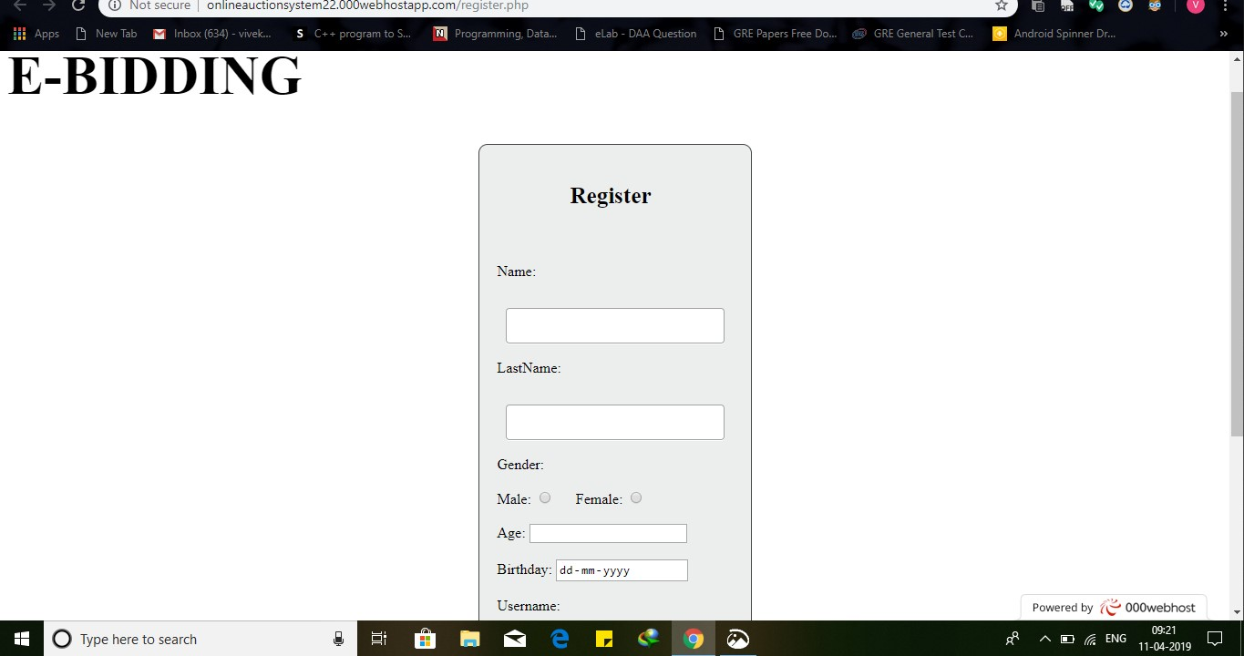

My Link: <https://bikerentalproject.000webhostapp.com/>

**The End**